1. **List of technologies and design patterns used**
   * Common Technologies used including MVC , SQL server , WCF , LINQTOSQL
   * Design patterns used includes Proxy, Strategy , Singleton and beside this system reach high leveling of separation of concerns and low coupling
2. **Sequence Diagram for the main scenario of the search process**

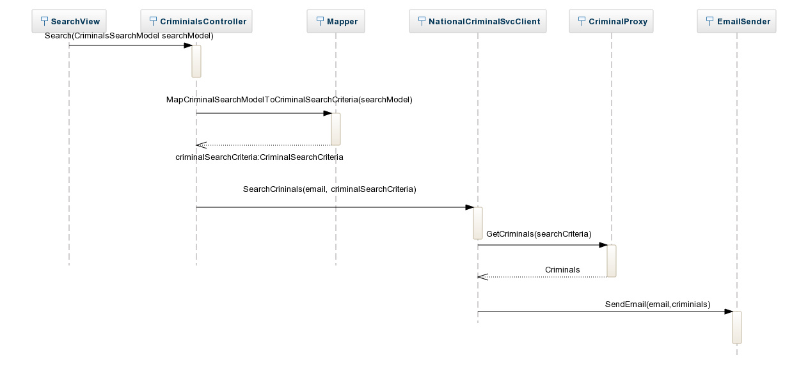

**3. Activity diagram for the search process**

Search for Criminal

Check User Is Authenticated

Search and return search result to user

Redirect to login page

Authenticated

Yes No